FEB 2026 version
ID: _

(PARAMETERS) | PHASE I | PHASE II | PHASE III
Site
Laterality | LEFT
Dose per PHASE | Gy | (cGy) | Gy | (cGy) | Gy | (cGy)
Dose per FRACTION | Gy/fx | (cGy/fx) | Gy/fx | (cGy/fx) | Gy/fx | (cGy/fx)
Cumulative DOSE | Gy | (cGy) | Gy | (cGy) | Gy | (cGy)
Total Fraction no. | fractions | fractions | fractions
SSD | 15 cm | 15 cm | 15 cm
Energy | 100 kV  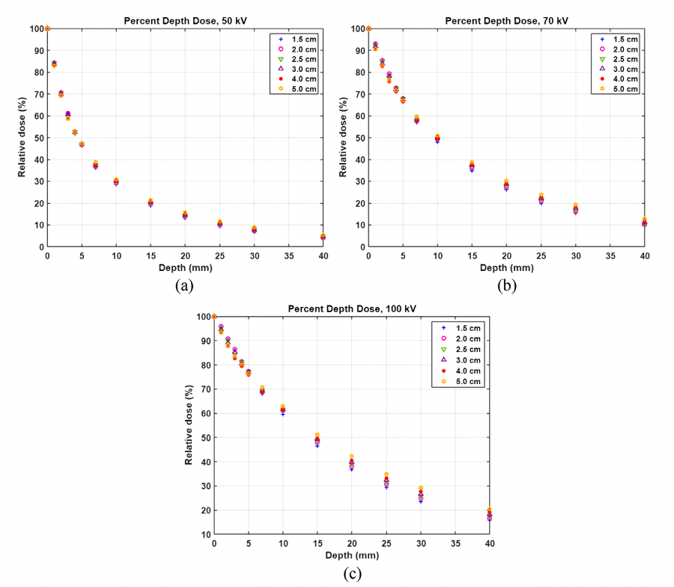 | 70 kV   | 50 kV  
Applicator size | Applicator Size | Applicator Size | Applicator Size
Verified Rx in Sensus EMR
Margin | mm around lesion | mm around lesion | mm around lesion
Technique | Superficial XRT | Superficial XRT | Superficial XRT
Lead Shield #1 Size | Circle, Radius _ cm | Circle, Radius _ cm | Circle, Radius _ cm
Lead Shield #2 Size | Circle, Radius _ cm | Circle, Radius _ cm | Circle, Radius _ cm
Lead Shield #3 Size | Circle, Radius _ cm | Circle, Radius _ cm | Circle, Radius _ cm
Thyroid Shield | YES | YES | YES
Lead Apron | YES | YES | YES
Nasal Bullet | None | None | None
Eye Shield Interior | None | None | None
Eye Shield Exterior | None | None | None
Lead Glasses | YES | YES | YES
Dose Rate | per plan | per plan | per plan
Beam Arrangement | En Face Kilovoltage Photons | En Face Kilovoltage Photons | En Face Kilovoltage Photons
Technique | Superficial XRT | Superficial XRT | Superficial XRT
Shielding Design(s)
Fractions per day
Fractions per week
Single or Multi phase
Standard Fractionation vs. Hypofractionation | Standard | Standard | Standard
Synchronous vs Sequential | Sequential | Sequential | Sequential
Imaging (77439 US) | 20 mHz: Daily isodose tracking dose to depth  50 MhZ: Weekly for comprehensive IGSRT | 20 mHz: Daily isodose tracking dose to depth  50 MhZ: Weekly for comprehensive IGSRT | 20 mHz: Daily isodose tracking dose to depth  50 MhZ: Weekly for comprehensive IGSRT
Alignment | Align lesion in center of field | Align lesion in center of field | Align lesion in center of field
Custom Block | NO | NO | NO
Complex Shielding (77263) | NO | NO | NO
In Vivo Dosimetry/Film | NO | NO | NO
GRID (Spatial Fractionation) | NO | NO | NO
Concurrent Therapy | NO | NO | NO
Prior RT | No prior RT | No prior RT | No prior RT
Pre-Authorized | NA | NA | NA
Consult Images
Outside Biopsy Image
(if any available)
SIM ORDER Drawn Target
Sim Image:
Inked Target
Sim Image:
Shielded nozzle view
Sim Image:
Side nozzle view
Depth of Target (DOT) (Ultrasound) | Depth of Target (DOT): _
Estimated tumor a/b* | 10 | 10 | 10
EQD2 for tumor (a/b_10)
EQD2 for OARs (a/b_3)
BED for tumor (a/b_10)
BED for OARs (a/b_3)
Electronically Signed by: | Clayton B. Hess, MD, MPH  Radiation Oncologist
Date Ordered: | Feb 24, 2026

Tab 2

